**Deployment of .Net core web application through the Azure DevOps on Azure cloud.**

Step1: Created a .net web application “WebApplication2”.

Step2: Uploaded the web Application code to Github through the git.

<https://github.com/balraamyadav/Demo-WebApp-DotNet>

Step3: On Azure Devops Portal created a project “Dotnet WebApplication”

3.1 - Pulled the Project code “WebApplication2” into the AzureDevops Repos

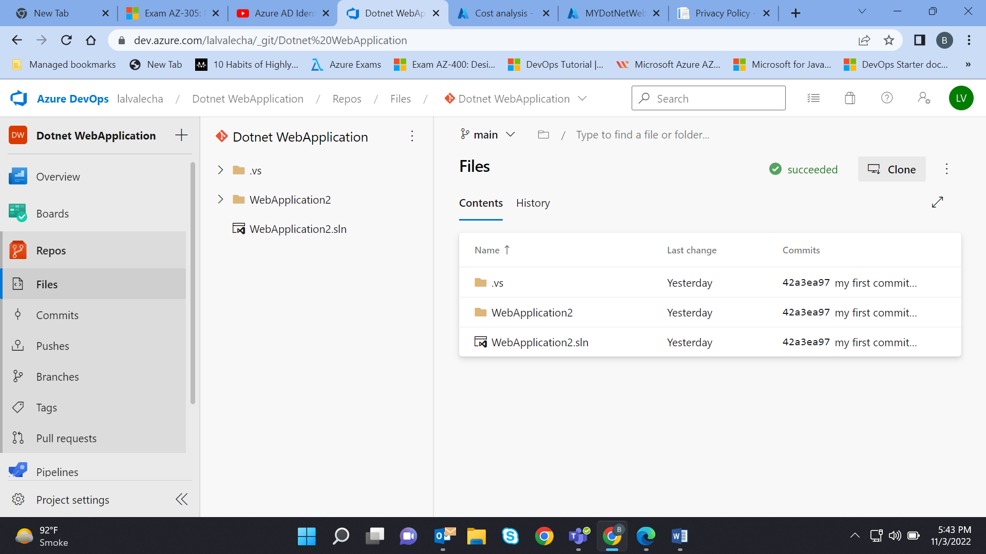

3.2- Created the Pipeline with the ASP.NetCore Agent for the Window OS and run it

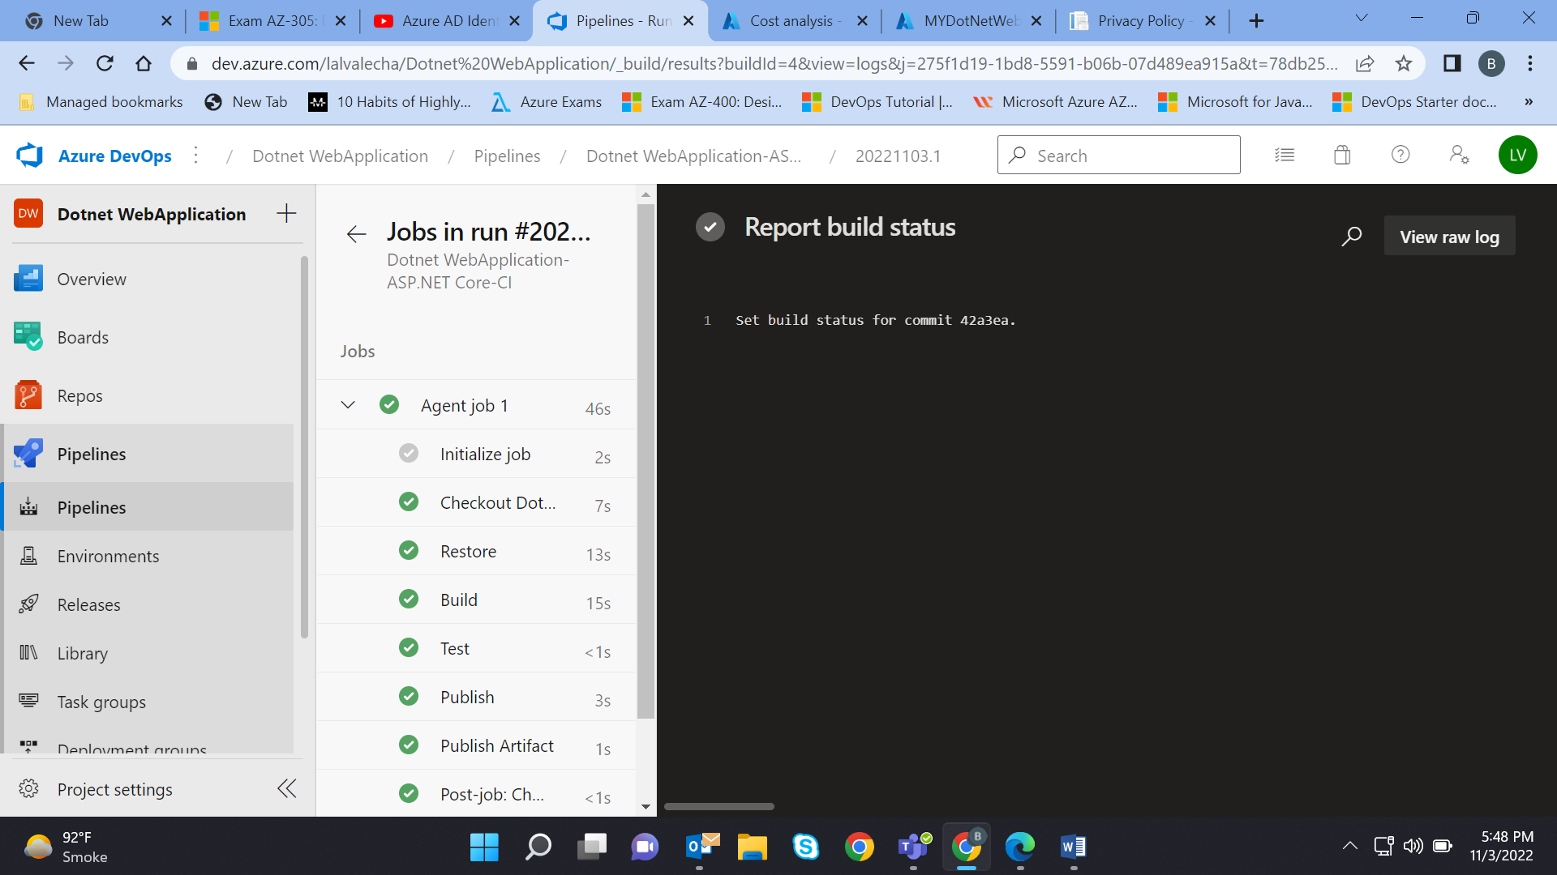

3.3 - Took the result of Continuous Integration (CI) which is a Drop file i.e Artifact

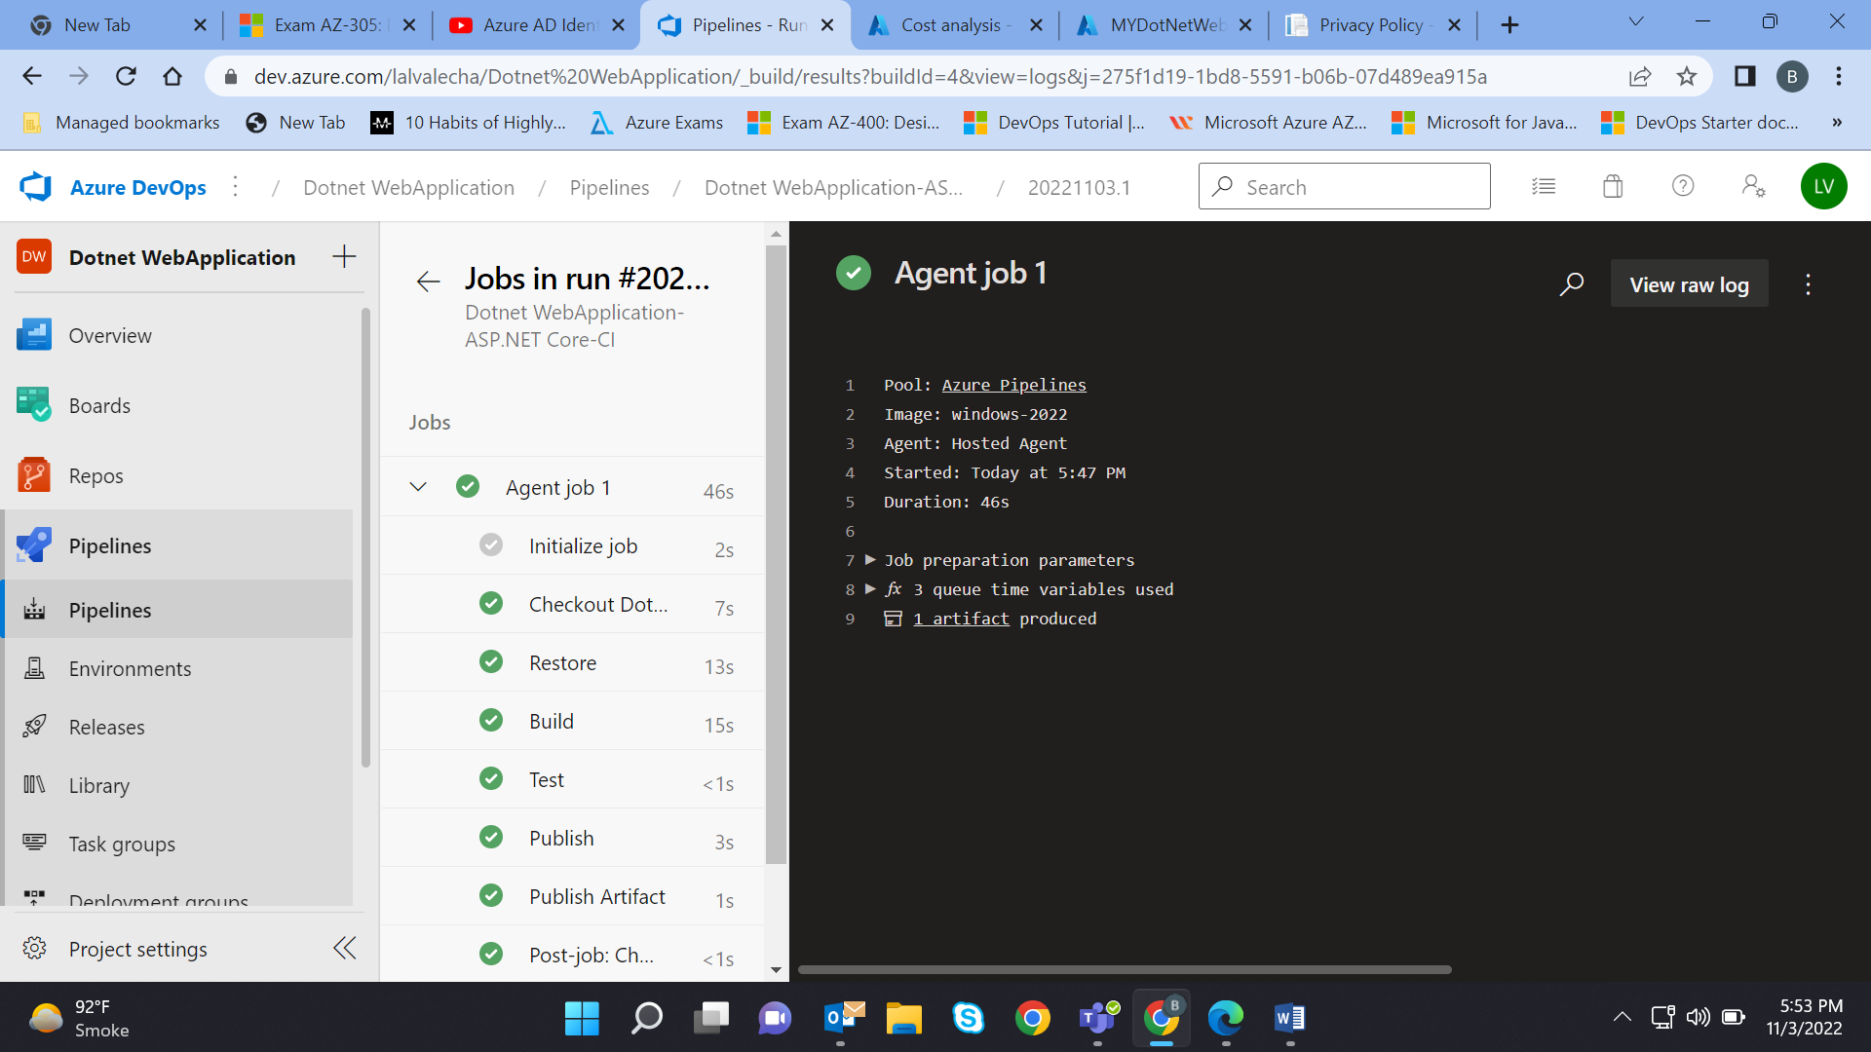

3.4 – Through the Azure Portal Created a window web app and run it successfully.

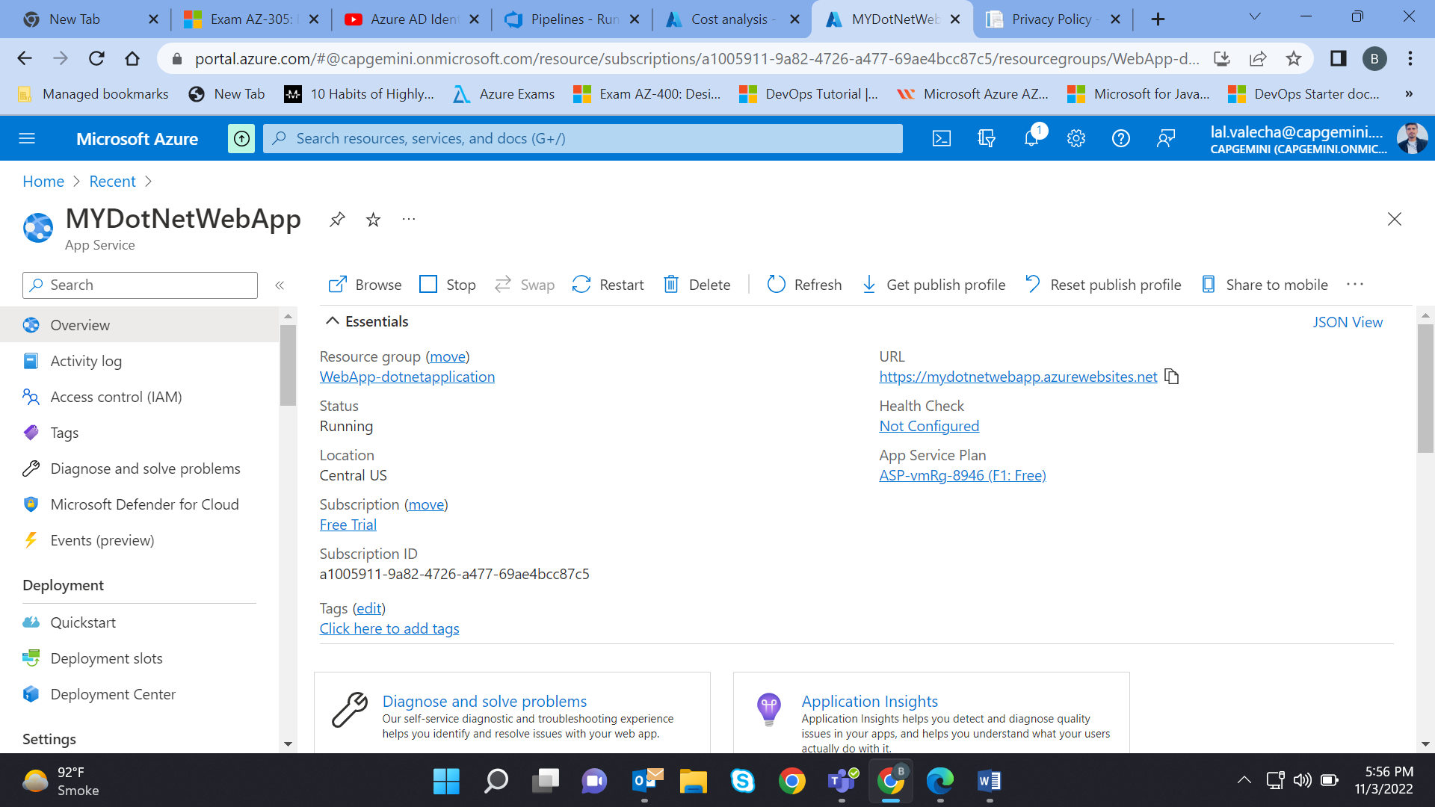

3.5- On the same MyDotNetWebApp Deployed the .net web application through the CD i.e Release pipeline 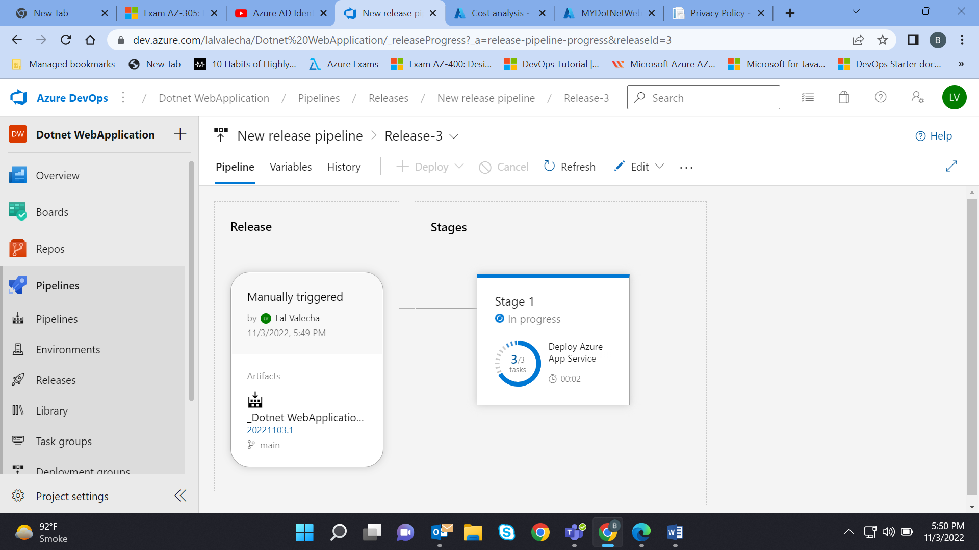

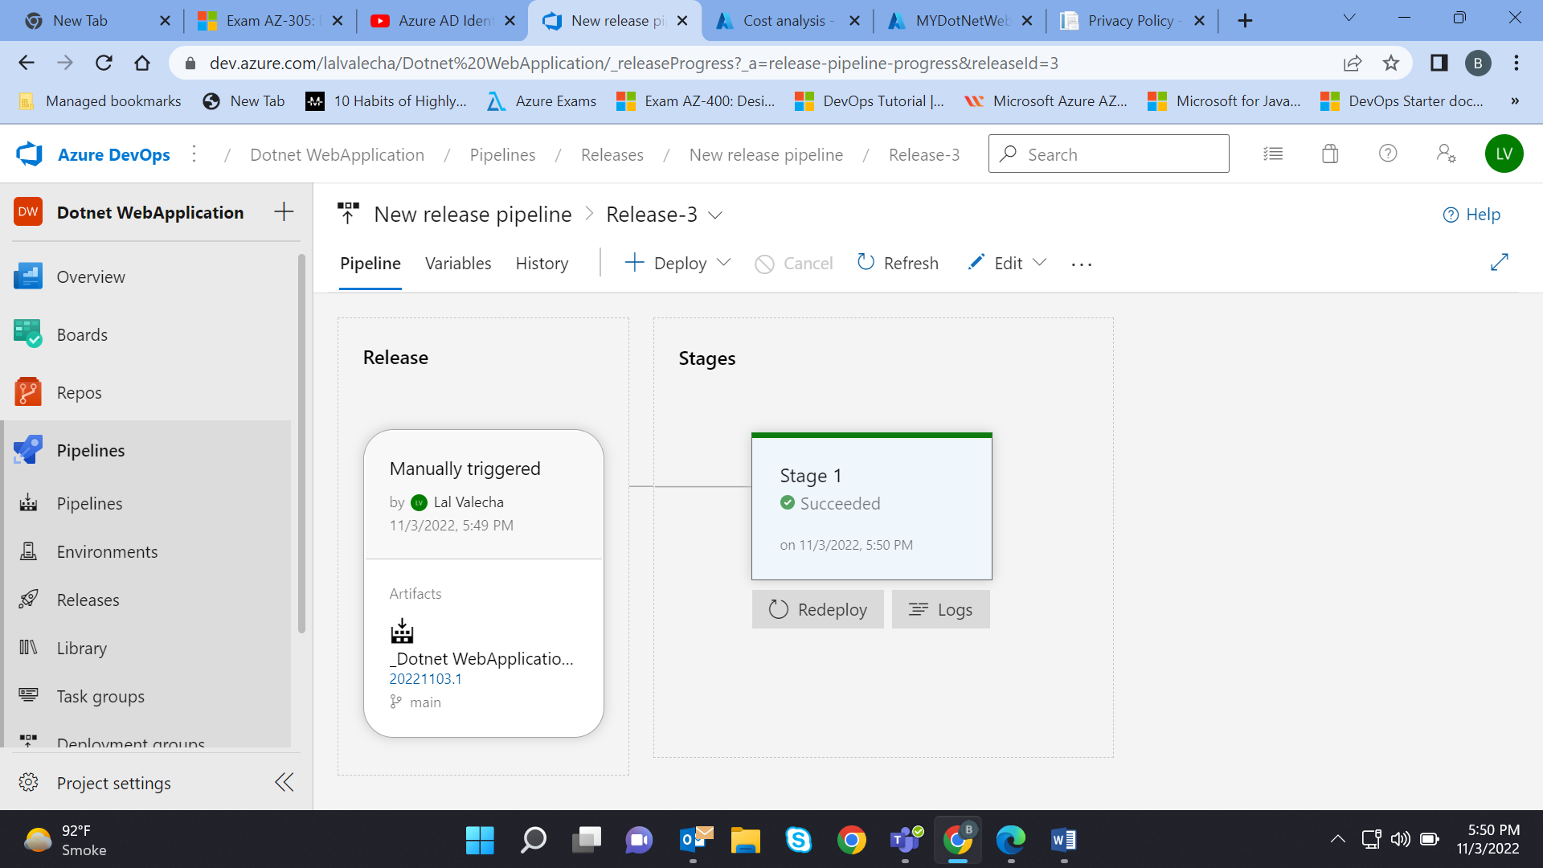

Deployment Link : <https://mydotnetwebapp.azurewebsites.net/>

